How to run PointOfSale using Eclipse

Revision History

|  |  |  |
| --- | --- | --- |
| Date | Author | Content |
| 09/03/2014 | Kenny Li | Initial. |
|  |  |  |

1. Unzip attachment to your [SourceCodeFolder]\PointOfSale
2. Import PointOfSale into Eclips & build project  
   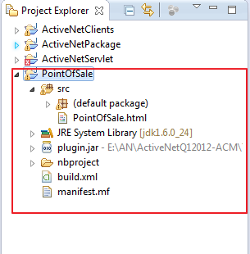
3. Export project to Jar  
   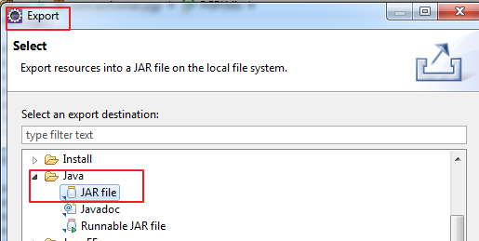
4. “Next” & setting it as following  
   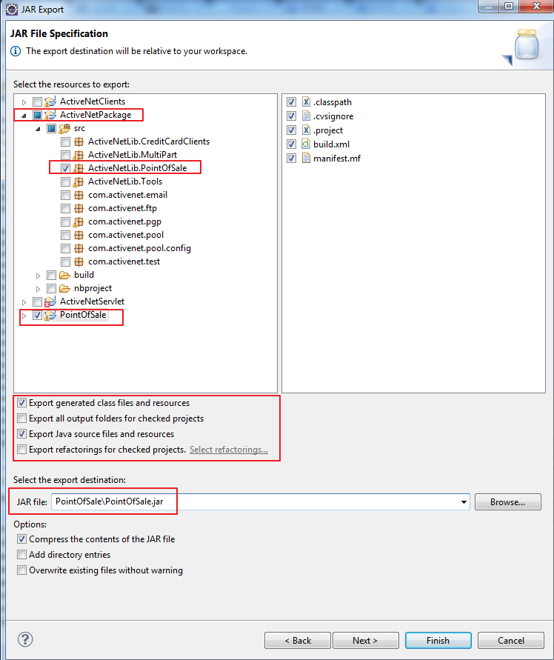

Go on next till finish

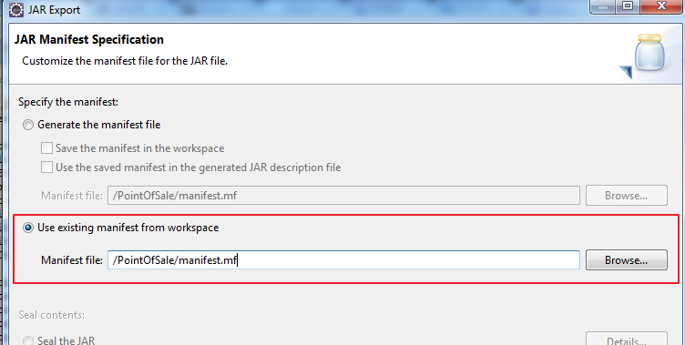

1. Run DeployPOS.bat  
   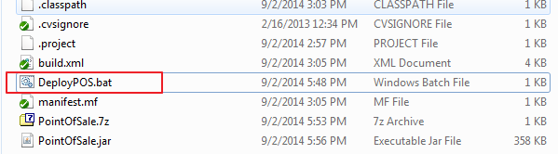

**Another Quick Way is**:

Get Latest PointOfSale.Jar from other member, put it into your [SourceCodeFolder]\ActiveNetServlet\Web, then done.